HEALTHCARE DATE ANALYSIS
PROJECT OVERVIEW: The objective of this project is to clean, organize, and prepare the dataset from the “Dataset” sheet for accurate analysis and reporting. The process ensures that the data is complete, consistent, and ready for transformation and visualization.
KEY STEPS PERFORMED:
1. Handling Missing Values
•Checked for missing entries in the ‘Price’ and ‘Category’ columns using Excel filters and conditional formatting.
•Replaced missing Price values using:
•Mean/Median imputation for numerical data.
•“Unknown” label or the most frequent value for categorical data like Category.
•Ensured no blanks remain by validating with Excel’s =COUNTBLANK() function.
2. Correcting Inconsistent Data
•Reviewed the ‘Product Name’ column for inconsistent capitalization and text formats.
•Used Excel functions like =PROPER() to standardize text formatting.
•Fixed typos and ensured consistent spellings in the ‘Category’ column using Find & Replace.
•Removed any extra spaces using the =TRIM() function.
3. Removing Duplicates
•Checked for duplicate records using Excel’s Remove Duplicates tool from the Data tab.
•Verified that only unique product entries remained, based on Product ID or Product Name.
4. Splitting and Merging Data
•Split columns: Divided the ‘Product ID’ field into separate columns for Manufacturing Date and Country Code using the Text to Columns feature.
•Merged columns: Combined ‘Brand Name’ and ‘Product Name’ into a new column named ‘Product Brand’ using:
5) Number Formatting:
• Format the data type of the "Price" column to currency format.
• Format the "Manufacturing Date" column to display dates in the "DD-MM-YYYY " format.
6) Conditional Formatting:
• Apply data bar or color scales conditional formatting in the "Price" column.
• Create a custom rule for conditional formatting in the "Category" column to highlight cells where the category is "Electronics."
Uncleaned data
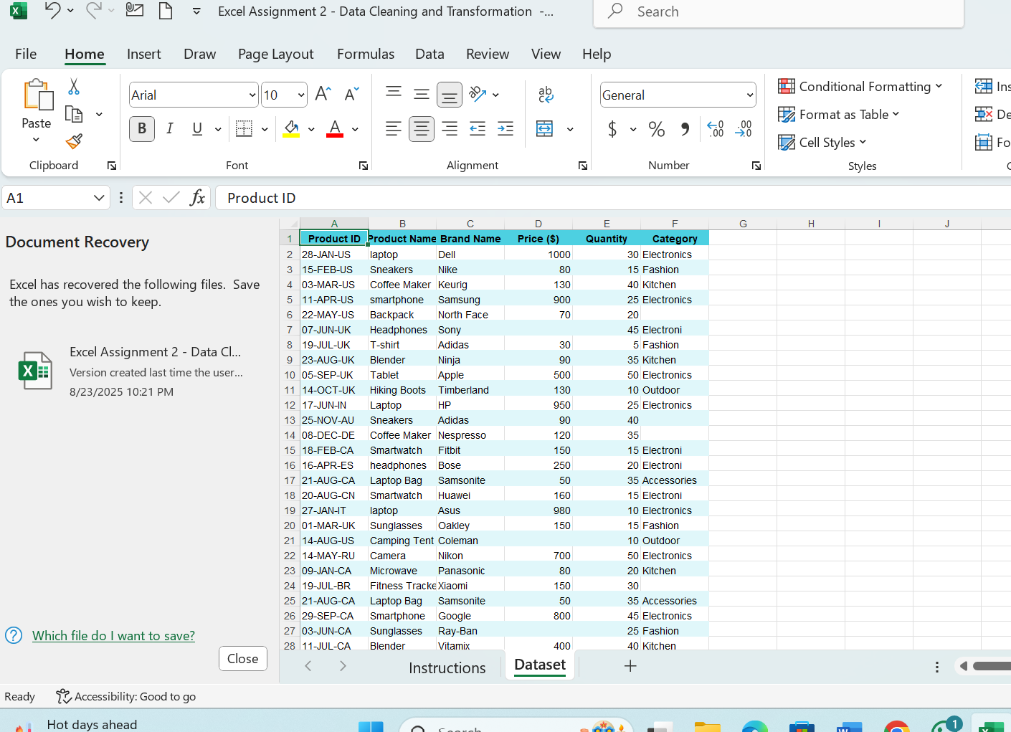
Cleaned data
